Welcome to Team Onair !

Hello members of Team Onair! Yup, you are thinking, what is ONAIR? In keeping with the Scottish traditions of our community, Onair is Scottish for Honor/Dignity/Strength.
This will be a very exciting year for you- your first year in Middle School! Your team of teachers is here to make the transition to the Middle School run smoothly. We will help you with all of those “Middle School Firsts”: changing classes, locker combinations, reading your schedule and getting around a new building. We are getting excited for a brand new school year and we can’t wait to meet you!
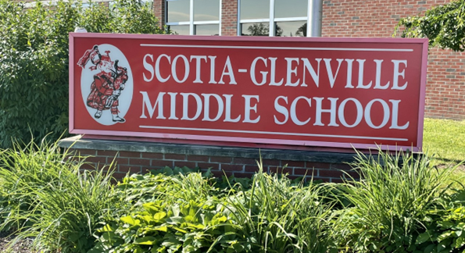

We believe these supplies are necessary for your child to be successful. Please keep this list handy throughout the summer so that as these items go on sale, you can maximize your savings! Please do not label the items with class names in advance. We will do this together, as a team in the fall. (However, you may put your own name on them, of course!) Please remember that some of these supplies will need to be replenished throughout the year. This is our suggested supply list:
Supply List
- 1 pack of colored pencils (package of 8-12 basic colors is fine)
- 1 highlighter for math notes (any color is fine)
- 2 packages of #2 pencils (to be replenished quarterly)
- 1 package of pens (blue or black ink suggested)
- 1 box of tissues PLEASE- we tend to go through a lot during the year
- 3 two-pocket plastic folders (preferably different colors-one for math, one for science, one for SS)
- 1 two-inch binder for ELA- any color is fine
- 1 two-inch binder for MATH – any color is fine
- Texas Instrument TI30xIIS calculator (used for the next 3 years of middle school)
- Earbuds or headphones to plug in to computer and chromebooks

For Foreign Language:  - loose - leaf paper  - pocket folders  - 30 index cards | For Phys Ed:  - Crew neck t-shirt and sweatshirt (no inappropriate logos)  - Elastic waist shorts (appropriate length)  - Socks, sneakers (that tie or velcro securely)  - Deodorant (stick) to keep in PE Locker
For Health:  - pocket folder | For Technology:  - pocket folder

AGENDA & Folder – You will be receiving a letter from the school with details about purchasing this year’s AGENDA and take-home folder. Keep an eye out for that letter, as it will give you all of the information you’ll need about purchasing the AGENDA and Folder.

If your family is unable to purchase school supplies at this time, please contact one of the teachers on the team so that we can be sure your child has what he or she needs when school begins. You may e-mail us or call the Middle School Main Office at 382-1263. Thank you.
E-Mail us!!!
shunt@sgcsd.net dbogue@sgcsd.net creed@sgcsd.net
sdelorenzo@sgcsd.net

As your child’s teachers this year, we would like to get to know your child as quickly as possible. We are aware of his/her academic abilities and past school performance, but there is so much more to the whole child that we want to learn, so we hope you will take the opportunity now to tell us about your son/daughter.

Please share with us anything you’d like us to know about your sixth grader. We look forward to hearing from you. Thank you!

