

TEAM HIGHLANDER
MRS. MORGAN, MR. MORTENSEN, MRS. ROSA, MR. SWAIN and MS. WILSON

We are pleased to welcome you to sixth grade in the Middle School. We hope you have enjoyed the summer and have had time for rest, relaxation, reading, sports and many activities with family and friends. As we get ready for the 2024-2025 school year, we want to give you some information to help you prepare and be ready for Thursday, September 5th.
A LITTLE ABOUT 6TH GRADE
In the Middle School you will experience more independence but also more responsibility! You will no longer have a teacher walk you from class to class (you will know your way around the school after the first week, we promise!).
With this new independence, you will be expected to act appropriately in the hallways and classrooms as well as be prepared for every class (that means bring everything you need for class to class).
*********************************************************************************************************************************
SIXTH GRADE CURRICULUM
Our team goal is to create a learning environment to engage all students. In sixth grade, you will be studying many interesting topics in both your core and encore classes. The core classes include English Language Arts, Math, Social Studies, and Science. The encore classes are those on your schedule that are not taught by us (Health, Technology, Foreign Language, P.E., Art, and Music).

Parents…Please E-mail Us!!!

As your child’s core teachers, we would like to get to know your child as quickly as possible. It would help us greatly if you would send us an e-mail telling us about your son or daughter to help us get to know them before the school year starts. Also, our team sends out a weekly e-mail letting parents know what the upcoming week looks like so please also send us the e-mail(s) you would like this weekly update sent to.

Just some ideas…

*what is special about your child?
*how does he/she feel about school?
*does your child have any special talents?
*what does your child enjoy doing (in and out of school)?

*what is your goal for your child?
*any other information you would like to share

kmorgan@sgcsd.net dswain@sgcsd.net mmortensen@sgcsd.net krosa@sgcsd.net

swilson1@sgcsd.net

We look forward to meeting you on Thursday, September 5th and to an exciting 6th grade year.
Enjoy the rest of your summer!

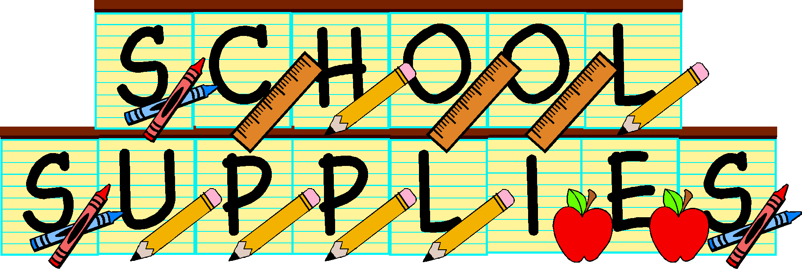
Team Highlander –Morgan/Mortensen/Rosa/Swain
Suggested Supplies - We believe these supplies are essential for a successful 6th grade year

- 4 plastic folders with pockets and three holes. As we use these the whole year, we have found the plastic ones to be more durable. Please label them with their name and the subjects, Math, Social Studies, ELA, and Science
- A two-inch binder with three rings to hold folders for ELA, Science Social Studies and Math
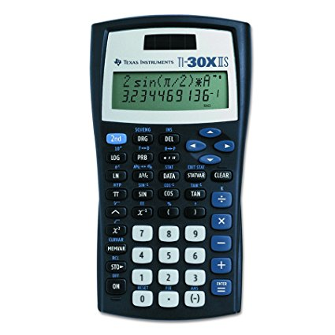
- A red folder which will be used as a Homework folder
- A pack of dry erase markers (Math)
- Loose-leaf paper (to be replaced throughout the year)
- 2 packs of pencils (to be replaced throughout the year)
- Texas Instruments TI-30X IIS 2 calculator
- 2 boxes of tissues
- A cheap set of earbuds to be used with Chromebooks

We strongly encourage the use of a durable pencil pouch with three holes to keep in binder, rather than the traditional toolboxes used in elementary school.

We will show you how to organize your binder and folders during the first weeks of school. We cannot stress enough how important it is to keep your materials organized. Being and staying organized will be a big help to you in Middle School.

Suggested for Encore classes
Technology Health Foreign Language
*1 pocket folder *1 pocket folder *Notebook (binder or spiral)
*1 pocket folder

Physical Education
*Crew neck t-shirt (long or short sleeve)
*Socks and sneakers
*Elastic waistband shorts (these shorts must be as long as your outstretched fingers hanging by your side and no writing is allowed across the back side of your shorts)
*Optional – sweatshirt and sweatpants and second set of PE clothing

